+ PROGRAME 01 :
DANANG - HOI AN - MY SON - DANANG
( 3 DAYS/ 2 NIGHTS )
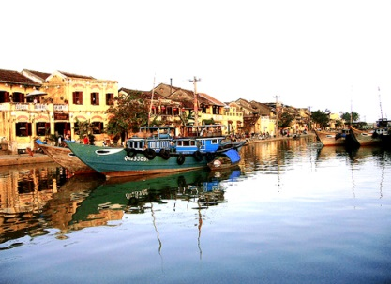
Day 01: Arrival Danang - Hoi An (L/- )
Meet on arrival at Danang International airport and visit Cham Museum, Marble Mountains, and Da Nang Beach before proceeding to Hoi An Ancient Town. Have lunch at a local restaurant - Discover the historic town was a prosperous seaport city during the 16th to 18th centuries. Its sizeable community of foreign merchants created a unique architectural style from Vietnamese, Chinese, and Japanese influences. You will have a walking tour of the Chinese Assembly Hall & Temples, ancient houses & Japanese Covered Bridge. Dinner and overnight in Hoi An.
Day 02: Hoi An - My Son – Hoi An (L/-)
Breakfast at the hotel.
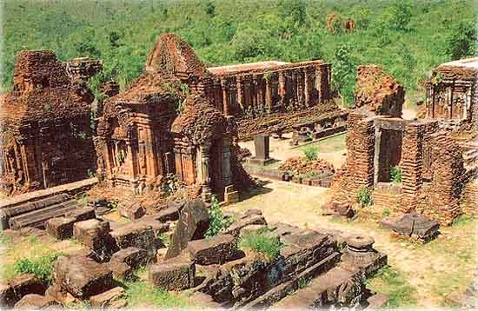
Full-day excursion to My Son Holy Land of the former Cham Kingdom (the ruins of the former Cham Capital in the 4th century), Vietnam’s most evocative Cham site recently named by UNESCO as a World Heritage site. The Cham people thought the shadow of Cat’s Tooth Peak was the domain of the gods and the religious and intellectual center of the culture. They inhabited the area continuously from the late fourth century A.D. until the 13th century. Excavations reveal kings’ tombs that date back to the fourth century. The towers are more than 1,300 years old and were built with bricks and carved as a final step. Have lunch at a local restaurant.
4Pm: Drive back to Hoi An and free for shopping.
Have dinner and overnight in Hoi An.
Day 03: Hoi An - Danang - Departure
At leisure time until transfer to Danang airport for departure (USD/Person)
Price | 1 | 2 | 3-5 | 6-9
Hotel 3 star | 370 | 212 | 173 | 132
Hotel 4 star | 385 | 200 | 238 | 142
Included:
- All transfers and excursion per tour programs
- Good English speaking guide
- Sightseeing fees & boat rides as mentioned in itinerary
- Meals as specified in program
Not included:
- International airfares
- Personal expenese, drinks, ... and the others not mentioned above.

+ PROGRAME 02 :
DANANG - HUE - HOI AN
( 4 DAYS/ 3 NIGHTS )
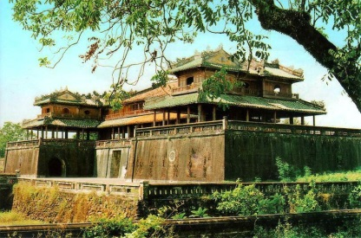
Day 01: Arrival Da Nang - Hue (D/-)
Meet on arrival at Danang and directly transfer to Hue via Hai Van Pass (Pass of the Ocean & Clouds), passing through many pretty red-tiled villages with fruit orchards, and enjoying spectacular views of sky and sea. Enjoy a seafood lunch at Lang Co fishing village. Upon arrival transfer to the hotel for check-in. Visit Imperial Citadel, Imperial Museum and Dong Ba market. Dinner at a local restaurant. Overnight in Hue.
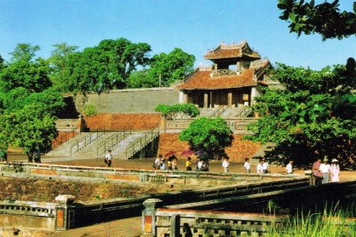
Day 02: Hue (L/-)
Breakfast at the hotel. Arrival visit Thien Mu Pagoda and Minh Mang tomb. Lunch at local restaurant followed by a visit to Tu Duc & Khai Dinh tombs. Dinner at local restaurant. In the evening: Free enjoy traditional folk music on boat. Overnight in Hue.
Day 03: Hue - Danang - Hoi An (L/-)
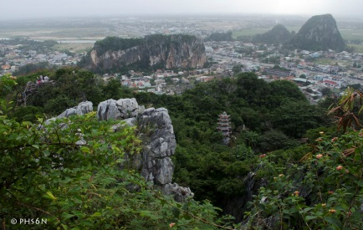
Breakfast at the hotel.
Drive back to Danang - Upon arrival visit Cham Museum, Marble Mountains and Da Nang Beach before proceeding to Hoi An Ancient Town. Lunch at local restaurant - Discover the historic town which used to be a prosperous seaport city during the 16th to 18th centuries. Its sizeable community of foreign merchants resulted in a unique architectural style with Vietnamese, Chinese and Japanese influences. Walking tour in Hoi An to Chinese Assembly Hall & Temples, ancient houses & Japanese Covered Bridge. Dinner and Overnight in Hoi An.
Day 04: Danang - Departure
Breakfast at the hotel.
Short city tour: Han River and market. Transfer to Danang airport for departure. (USD /Person)
Group | 1 | 2 | 3-5 | 6-9
Hotel 3 star | 532 | 278 | 235 | 197
Hotel 4 star | 600 | 307 | 264 | 206
Included:
- All transfers and excursion per tour programs
- Good English speaking guide
- Sightseeing fees & boat rides as mentioned in itinerary
- Meals as specified in program
Not included:
- International airfares
- Personal expenese, drinks, ... and the others not mentioned above.

+ PROGRAME 03 :
DANANG - HOI AN- MY SON - HUE
(5 DAYS/ 4 NIGHTS)

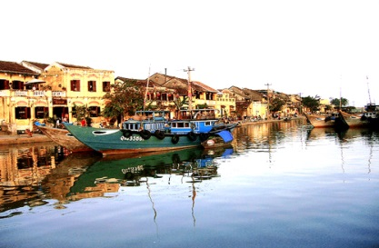
Day 01: Arrival Danang - Hoi An (L/-)
Meet on arrival at Danang International airport and visit Cham Museum, Marble Mountains, and Da Nang Beach before proceeding to Hoi An Ancient Town. Have lunch at a local restaurant - Discover the historic town was a prosperous seaport city during the 16th to 18th centuries. Its sizeable community of foreign merchants created a unique architectural style from Vietnamese, Chinese, and Japanese influences. You will have a walking tour of the Chinese Assembly Hall & Temples, ancient houses & Japanese Covered Bridge. Dinner and overnight in Hoi An.
Day 02: Hoi An - My Son - Hoi An (L/-)
Have breakfast at the hotel. Begin the day with an excursion to My Son Holy Land of the former Cham Kingdom (the ruins of the former Cham Capital in the 4th century). Have lunch at a local restaurant. This afternoon you will visit Thanh Ha Pottery village. At every turn, you will see the remarkable tenacity of the local people as they work at their craft that has passed through generations. Courtyards are lined with hand-cut bricks, drying in the accommodating sun. Village elders turn the potting wheels while their children shape the vessels.. Have dinner at a local restaurant and Overnight in Hoi An.
Day 03: Hoi An - Danang - Hue (L/-)
Breakfast at the hotel. In the morning, drive to Hue via Hai Van Pass (Pass of the Ocean & Clouds), pass through many pretty red-tiled villages with fruit orchards, and enjoy spectacular views of the sky and sea. Upon arrival at the hotel for check-in. Have lunch at a local restaurant.
P.m.: Visit Imperial Citadel, Imperial Museum and Dong Ba market. Have dinner at local restaurant. Overnight in Hue.
Day 04: Hue city tour (L/-)
Breakfast at the hotel. Visit Thien Mu Pagoda and Minh Mang tomb. Have lunch at local restaurant followed by a visit to Tu Duc & Khai Dinh tombs. Free Overnight in Hue.
Day 05: Hue - Departure
Have breakfast at the hotel. Leisure time until transfer to Phú Bài Airport for departure.

(USD / person)
Price | 1 person | 2 persons | 3-5 person | 6-9 person
Hotel 3 star | 768 | 422 | 360 | 211
Hotel 4 star | 787 | 436 | 422 | 225
Included:
- All transfers and excursion per tour programs
- Good English speaking guide
- Sightseeing fees & boat rides as mentioned in itinerary
- Meals as specified in program
Not included:
- International airfares
- Personal expenese, drinks ... and the others not mentioned above.

+ PROGRAME 04 :
DANANG - HOI AN - HUE –PHONG NHA
(5 DAYS/ 4 NIGHTS)
Day 01: Arrival Danang - Hoi An (L/-)
Meet on arrival at Danang International airport and visit Cham Museum, Marble Mountains, and Da Nang Beach before proceeding to Hoi An Ancient Town. Have lunch at a local restaurant - Discover the historic town was a prosperous seaport city during the 16th to 18th centuries. Its sizeable community of foreign merchants created a unique architectural style from Vietnamese, Chinese, and Japanese influences. You will have a walking tour of the Chinese Assembly Hall & Temples, ancient houses & Japanese Covered Bridge. Dinner and overnight in Hoi An.
Day 02: Hoi An - Bay Mau Coconut forest (L/-)
Have breakfast at the hotel. Visit Bay Mau Coconut Forest on basket boats - a typical vehicle of the fishing village of Van Lang village. You can witness firsthand the local people casting their nets on the river to catch fish and you can also experience your own casting skills. After that, watch the remarkable basket-shaking performance by Van Lang artist.
You can freely visit the space of the eco-tourism area, then gather to participate in fun folk games with prizes: bridge walking, pot breaking, and bag jumping.
Have lunch with typical village flavor. Leave Bay Mau Coconut Forest.
2h30 pm. Departure to Hue. Have dinner at a local restaurant in Hue. Overnight in Hue.
Day 03: Hue- Phong Nha Cave (L/-)
Have breakfast at the hotel. In the morning, drive to Phong Nha cave, passing through Hien Luong.
Have luch at a local restaurant in Phong Nha. Phong Nha - one of the most beautiful cave of VietNam with magnificent wonders. Then come back to Hue.
Have dinner at Hue local restaurant. Overnight at Hue.
Day 04: Hue city tour (L/-)
Have breakfast at the hotel. Boat trip on Perfume River to Thien Mu Pagoda and Minh Mang tomb. Have lunch at a local restaurant followed by a visit to Imperial Citadel, Dong Ba market. Have dinner at a local restaurant. Overnight in Hue.
Day 05: Hue - Departure
Breakfast at the hotel. Leisure time until transfer to Hue Airport for departure.
(USD/ person)
Price | 1 person | 2 persons | 3-5 person | 6-9 person
Hotel 3 star | 763 | 456 | 408 | 259
Hotel 4 star | 797 | 480 | 427 | 232
Included:
- All transfers and excursion per tour programs
- Good English speaking guide
- Sightseeing fees & boat rides as mentioned in itinerary
- Meals as specified in program
Not included:
- International airfares
- Personal expenese, drinks.. ... and the others not mentioned above.

